Modelling Scientists: Your Name:
As scientists’ understanding of atoms has grown, they have developed new models to represent atoms. Refer to the Science as a Human Endeavour on page 8 of the Year 9 book to read more about the development of atomic models. If you cannot find any information in that book, use Wikipedia! These scientists all improved the scientific model for the “atom”.

Scientists Name | Picture | The model they proposed or the experiments they made famous! | What date did they live?
Niels Bohr
Ernest Rutherford
Modern atomic physicists
Democritus

Werner Heisenberg
Dimitri Mendeleev | 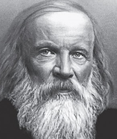
Marie Curie
Enrico Fermi

Questions and Activities
- Make a time line for when these scientists live
- Write a short account of the model they proposed or do question 3 below if you cannot find out what model they proposed.
- Write what experiments they did to develop their understanding of the model
- Email your answer to Mr Widmer ( widmerjo@werribeesc.vic.edu.au )

